1. Lenz’s law describes how an induced current in a conductor will generate a magnetic field that will oppose the original magnetic field. If there was a slit cut into the Copper, there would be an incomplete loop, meaning that there would be no current and no secondary magnetic field to oppose the magnetic field from the original magnet. The magnet would then fall like a normal object through the tube.
2. Bcenter = 0.0371 T Bouter = 0.0043 T  
   R = 0 cm Rcoil = 0.01905 cm $m= \frac{0.0043 T-0.0371 T}{0.01905 cm-0 cm}=-0.172$ 
    b = 0.0043  
   B(r) = -0.172**r** +0.0043
$φ= \int_{0}^{2π}{dθ\int_{0}^{1.905}{\left(-0.172r +0.0043\right) rdr}}$ $$φ= \int_{0}^{2π}{dθ\int_{0}^{0.01905}{\left(-1.72r^{2} +0.0043r\right) dr}} \\ φ= \int_{0}^{2π}{dθ} \left(\frac{-1.72}{3}r^{3}+\frac{0.0043}{2}r^{2}\right)|_{0}^{0.01905} \\ φ= \int_{0}^{2π}{dθ} \left(-3.1834 x {10}^{-6}\right) \\ φ= 2π\left(-3.1834 x {10}^{-6}\right)= -2.000 x 10^{-5} Wb$$

4. Section 5

Capacitance: 1.061 ± 0.0011 µF Resistance: 101.3 ± 0.1 kΩ

Dinner = 1.96 ± 0.01 cm Douter = 3.81 ± 0.01 cm ravg = 1.45 ± 0.01 cm

Voltage Measurements

|  |  |
| --- | --- |
| Voltage number | Voltage Value (V) |
| 1 | -0.430 |
| 2 | -0.427 |
| 3 | -0.458 |
| 4 | -0.435 |
| 5 | -0.458 |
| 6 | -0.457 |
| 7 | -0.455 |
| 8 | -0.448 |
| 9 | -0.414 |
| 10 | -0.435 |
| 11 | -0.434 |
| 12 | -0.439 |
| 13 | -0.449 |
| 14 | -0.457 |
| 15 | -0.445 |
| 16 | -0.446 |
| 17 | -0.453 |
| 18 | -0.451 |
| 19 | -0.453 |
| 20 | -0.441 |

Vavg = -0.444 V $(-1)(\frac{0.430+0.427+0.458+0.435+0.458+0.457+0.455+0.448+0.414+0.435+0.434+0.439+0.449+0.457+0.445+0.446+0.453+0.451+0.453+0.441}{20})$

0.012 V = $Vσ= \sqrt{\frac{\sum_{1=1}^{n}{{((V_{i}-V_{avg})}^{2})}}{n}}$

V = -0.444 ± 0.012 V

$V_{c}= \frac{φ_{tot}}{RC}$ φtot = RC(Vc) φσ = $\sqrt{{((RC)(δV))}^{2}+{((CV)(δR))}^{2}+{((RV)(δC))}^{2}}$

Φ = -0.0477 ± 0.0012 Wb

Bcenter = 0.0371 ± 0.0003 T Bouter = 0.004278 ± 0.00011 T

Absolute value of flux from #3: 2.000x10-5 Wb

2000 coils = n

2000(2.000 x 10-5) = 0.04000 Wb

$T= \frac{\left|x_{theo}-x_{expt}\right|}{\sqrt{σ_{theo}^{2}+σ_{expt}^{2}}}$ = 6.42

Section 6

Magnet Length (l) = 5.00 ± 0.01 cm Magnetic Field strength (B) = 3420 ± 10 Gauss

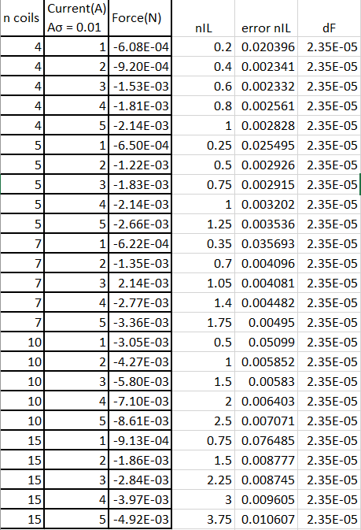

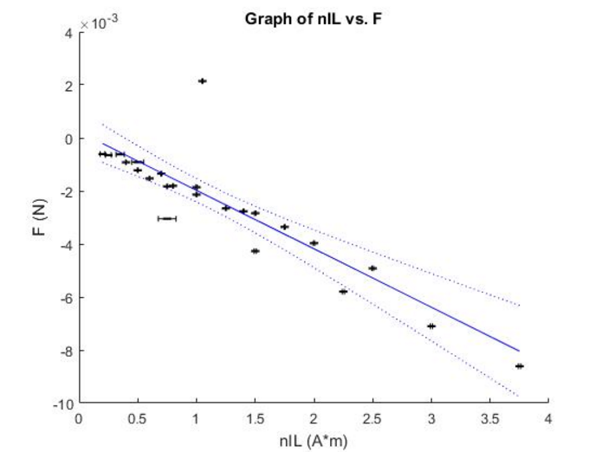

Parameter 1: p(1) = -2.205376e-03 +/- 3.039355e-04

Parameter 2: p(2) = 2.276356e-04 +/- 3.956166e-04

Parameter m = -2.205376e-03 +/- 3.039355e-04

Parameter b = 2.276356e-04 +/- 3.956166e-04

|m| = B = 2.2 x10-3 ± 0.3 x 10-4 T

B =

T = 339.7999998 🡪 Basically the experimental value is useless

Discussion

1. There are certain assumptions that can be made based on the information given. It is first assumed that the magnetic field lines within the coil may not be straight lines, meaning that there will be some interference. One other assumption that is made is that the magnetic fields would not interfere with each other, even though it would have a great affect in real life. The entire stack is assumed to have only a single collective magnetic field. Another Assumption is that the Capacitor did not accumulate the maximum amount of charge that it could have taken, and it would result in the components obeying Ohm’s law. Assuming that the magnetic fields are straight lines within the magnet, there is no interference between loops, and that the circuit would obey Ohm’s law. These last few assumptions are not safe to make because the interference of the fields between the of the individual loops and the assumption of the following of Ohm’s law is dangerous, partly because in reality, Capacitors, even though they are not fully charged, do not dissipate energy in the way that regular resistors do. Also, there is the fact that the capacitor does not behave as intended because it may not have ever been fully charged. The magnetic fields would only not interfere with each other if the fcoil was condensed into a single block. One way to correct for interference between the coils is to reconstruct the coil into a uniform radius loop with each loop having the same radius, unlike in this setup, this would help to reduce interference between the loops. The use of an Rc circuit calculation would be used to measure the voltage across the capacitor to determine the voltage drop over the capacitor.